**PATIENCE CELE**

**JAVA BASIC DOCUMENTATION**

**29-09-2022**

**SECTION A**

**QUESTION 1**

**DIFFERENCES BETWEEN HASHMAP AND LINKEDHASHMAP**

1. linkedHashMap returns values in the order of their insertion and hashMap returns values in a random order.
2. linkedHashMap uses HashTable and LinkedList, hashMap only uses HashTable
3. linkedHashMap extends hashMap and hashMap extends abstractMap and implements Map interface.

**QUESTION 2**

**EDUVOS CLINIC**

The Eduvos clinic app allows the user to register the patient and store patient’s details on their database using Java application.

Details needed to register the user are:

|  |  |  |
| --- | --- | --- |
| GENERAL DESCRIPTION | JAVA | DATABASE |
| Patient system identification number | id | patID |
| Patient name | name | patName |
| Patient surname | surname | patSurname |
| Patient cell phone number | cell | patCellNo |
| Patient student number | studNo | patStudNo |

The application uses the student number to terminate the program. The program will request the user to insert the student number(studNo) and it will check if the student number doesn’t equal to “0” (zero) and if it does, it will terminate the program, otherwise the program will request for the rest of the details: name, surname, cell and id in their respective order. Once the user has provided the details, the system will have the details to the database and alert the user that information has been saved.

The system also validates cell number and identification number to ensure that they are all integers, and no other characters are added. If a user gives invalid input, the system will let the user know that they have inserted incorrect values and they need to provide correct details again

The program connects to the database using Microsoft SQL SERVER driver with below details:

url = "jdbc:sqlserver://localhost:1433;databaseName = clinic";

user = "JavaStudent";

password = "1234";

**RESULT SCREENSHOTS**

**JAVA PROGRAM RESULTS**

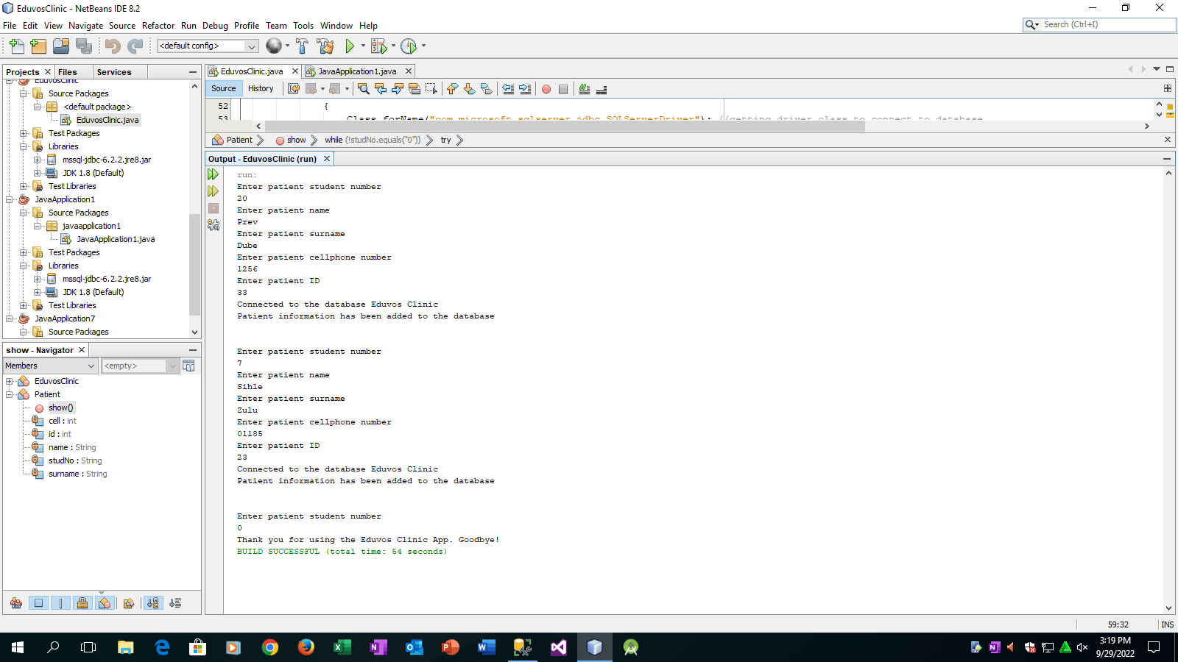

**DATABASE RESULTS**

